COP 2800
Assignment 2

This week we are going to write a program that calculates wages for three employees. The screen shot is a sample run showing how your program should work.

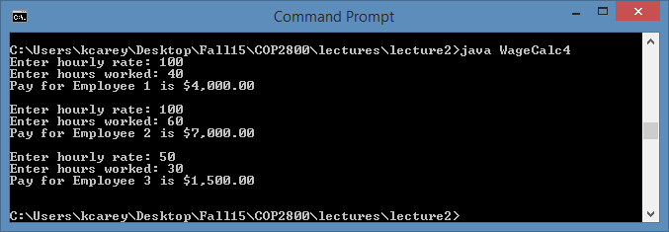

Examine the input and output for employee 2 above. Employees that work more than 40 hours are paid ‘time and a half’, i.e. 1.5 times their normal rate, for hours above 40.

You do not have to input employee names, just call them 1, 2, and 3. However, the majority of your program should be done in a loop, i.e. there should be only one statement that prompts for hourly rate, etc.

Submit just the .java file to Assignment 2. Files that do not compile will receive a grade of 0.

I think some of us could use a brush up on basic programming; give this one a shot…

Prompt the user for 3 unique numbers and then output the numbers in ascending order. If a duplicate is entered, output an error message.

Note: This is not an extra credit program and should not be submitted to D2L; it is just for your own practice in basic programming. However, if you have difficulty, drop me an email with your code attached.

